Actividades para segundo
Observa las ilustraciones, identifica cada una de ellas y escribe el número en el círculo correspondiente, finalmente en tu cuaderno escribe cada una de las ocupaciones y profesiones en inglés y español.
Sigue el ejemplo: 1. Accountant= contador 2. Actor= actor 3. Archaeologist= arqueólogo etc.
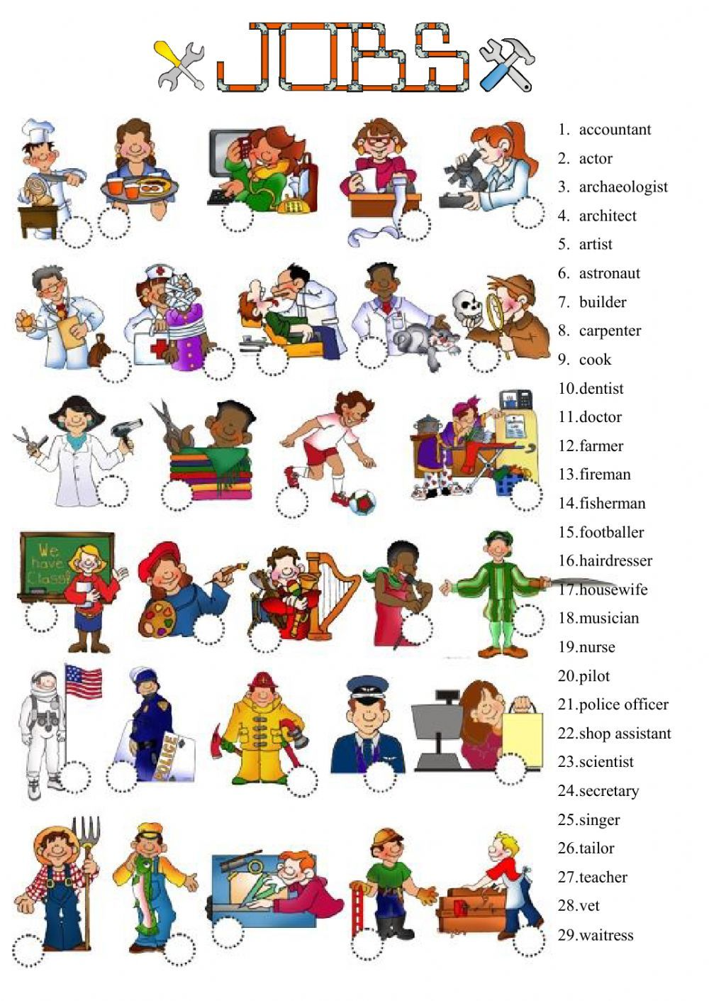
Lee con atención el siguiente tema, cuando lo hayas comprendido realiza los ejercicios en tu cuaderno que se encuentran en la parte de abajo .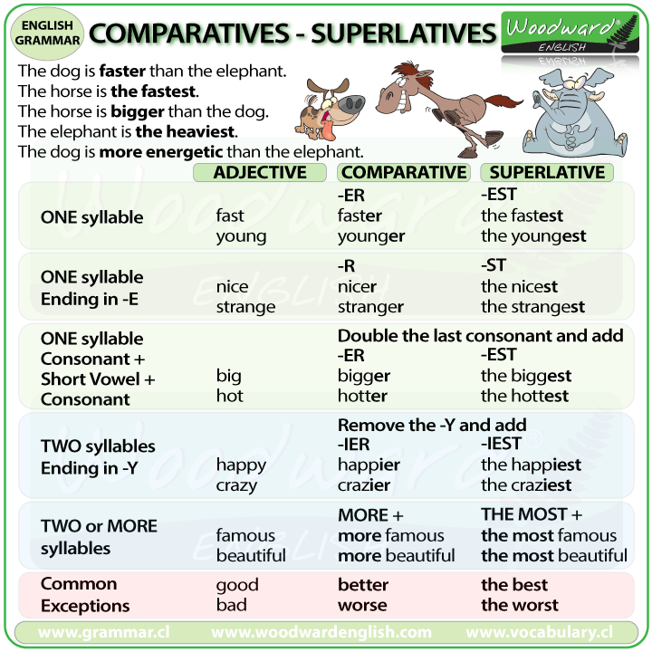
Adjectives | Comparatives | Superlatives
bad | worse | worst
far(distance) | farther | farthest
far(extent) | further | furthest
good | better | best
little | less | least
many | more | most
much | more | most

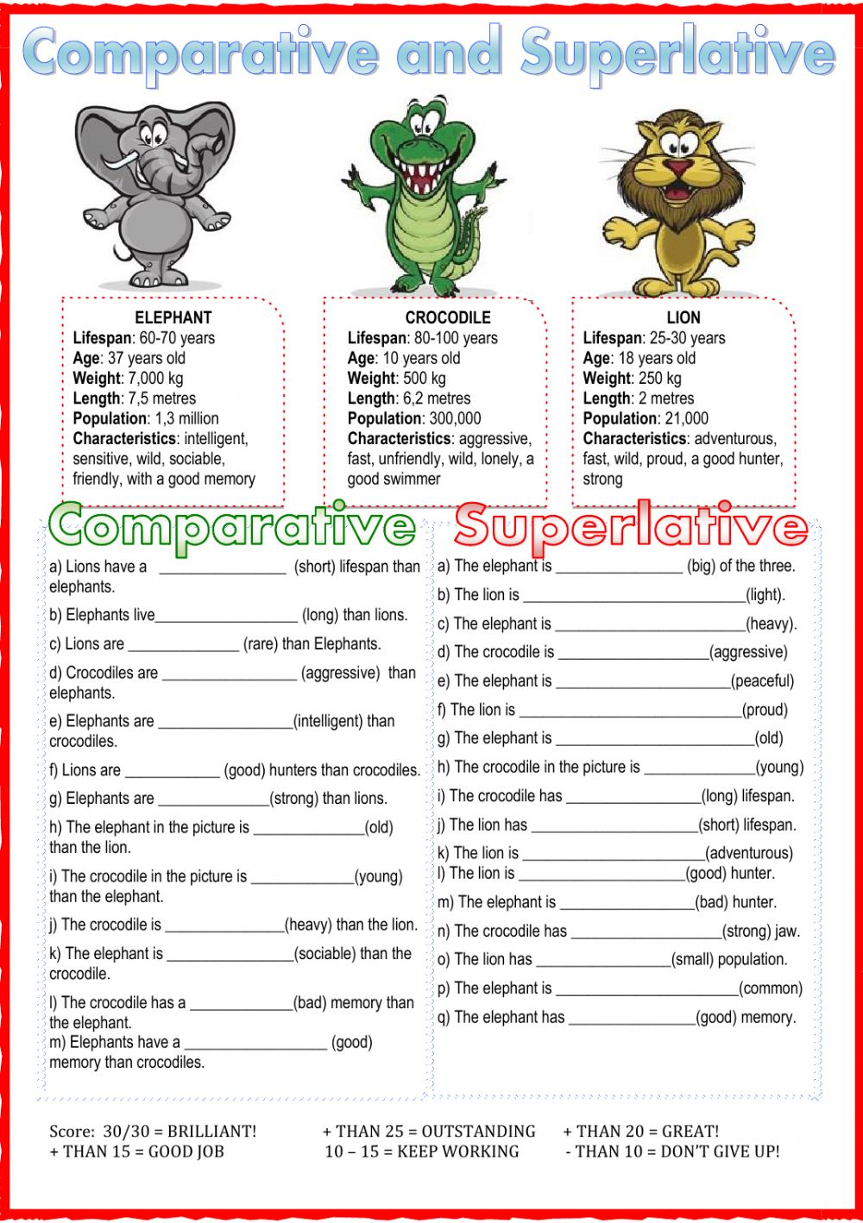
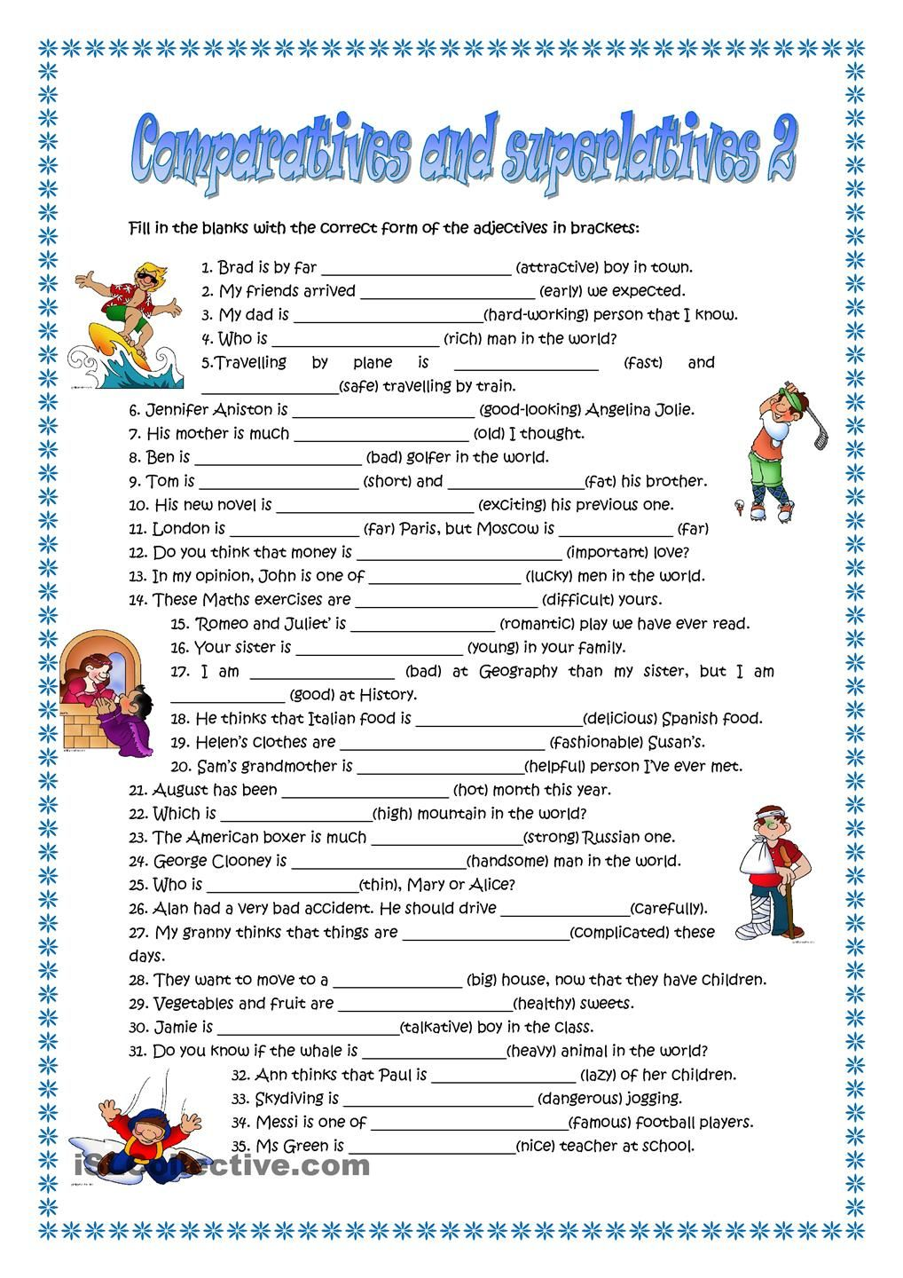

Aquí tienes una gran cantidad de ejemplos en los cuales te puedes apoyar para el mejor entendimiento de los comparativos y superlativos.
Anxious - more anxious - most anxious  - Big - bigger - biggest  - Brave - braver - bravest  - Bright - brighter - brightest  - Broad - broader - broadest  - Calm - calmer - calmest  - Cold - colder - coldest  - Cool - cooler - coolest  - Curly - curlier - curliest  - Dark - darker - darkest  - Dirty - dirtier - dirtiest  - Dull - duller - dullest  - Dry - drier - driest  - Early - earlier - earliest  - Easy - easier - easiest  - Embarrassed - more embarrassed - most embarrassed  - Evil - more evil - most evil  - Famous - more famous - most famous  - Fine - finer - finest  - Fresh - fresher - freshest | - Hard - harder - hardest  - Heavy - heavier - heaviest  - Immense - more immense - most immense  - Late - later - latest  - Light - lighter - lightest  - Long - longer - longest  - Lovely - lovelier - loveliest  - Nervous - more nervous - most nervous  - New - newer - newest  - Old - older - oldest  - Perfect - more perfect - most perfect  - Quick - quicker - quickest  - Rich - richer - richest  - Sad - sadder - saddest  - Simple - simpler - simplest  - Small - smaller - smallest  - Smart - smarter - smartest  - Soft - softer - softest  - Sweet - sweeter - sweetest  - Thin - thinner - thinnest

Sentences with Comparitive Adjectives  - My house is bigger than yours.  - Your grade is worse than mine.  - The Pacific Ocean is deeper than the Arctic Ocean.  - You are more polite than Joey.  - My brother is taller than me, but he is younger, too.  - A rose is more beautiful than a daisy.  - The Earth is larger in diameter than the moon.  - A pint is less than a quart.  - Learning Japanese is more difficult than leaning Italian.  - It is farther from New York to Austin than it is from New York to Nashville. | Sentences with Superlative Adjectives  - I can't find my most comfortable jeans.  - The runt of the litter is the smallest.  - Jupiter is the biggest planet in our Solar System.  - She is the smartest girl in our class.  - This is the most interesting book I have ever read.  - I am the shortest person in my family.  - Jerry is the least worried about the game.  - That was the best movie ever.  - Sam is the most handsome boy in the whole school.  - Mount Everest is the highest mountain in the world.

Lee las lecturas y con la ayuda de tu diccionario contesta las preguntas.
Preparing food
Jack was hungry. He walked to the kitchen. He got out some eggs. He took out some oil. He placed a skillet on the stove. Next, he turned on the heat. He poured the oil into the skillet. He cracked the eggs into a bowl. He stirred the eggs. Then, he poured them into the hot skillet. He waited while the eggs cooked. They cooked for two minutes. He heard them cooking. They popped in the oil.
Next, Jack put the eggs on a plate. He placed the plate on the dining room table. Jack loved looking at his eggs. They looked pretty on the white plate. He sat down in the large wooden chair. He thought about the day ahead. He ate the eggs with a spoon. They were good.
He washed the plate with dishwashing soap. Then, he washed the pan. He got a sponge damp. Finally, he wiped down the table. Next, Jack watched TV.
Question 1:
What food was cooked?
1 Fish 2 Eggs
3 Rice 4 Pork
Question 2:
Where did Jack eat the eggs?
1 At the dining room table 2 In the kitchen
3 In front of the TV 4 In his room
Question 3:
How long did the eggs cook?
1 3 minutes 2 5 minutes
3 2 minutes 4 10 minutes
Question 4:
What was the chair made of?
1 Stone 2 Metal
3 We do not know 4 Wood
Question 5:
Jack cooked in a skillet. What is another word for skillet?
1 Microwave 2 Slow cooker
3 Pan 4 Oven

Lee la lectura y contesta las preguntas
The House
Mr. and Mrs. Smith have one son and one daughter. The son's name is John. The daughter's name is Sarah.
The Smiths live in a house. They have a living room. They watch TV in the living room. The father cooks food in the kitchen. They eat in the dining room. The house has two bedrooms. They sleep in the bedrooms. They keep their clothes in the closet. There is one bathroom. They brush their teeth in the bathroom.
The house has a garden. John and Sarah play in the garden. They have a dog. John and Sarah like to play with the dog.
Question 1:
How many children do Mr. and Mrs. Smith have?
1 One daughter 2 One son
3 One son and one daughter 4 No children
Question 2:
Who cooks in the kitchen?
1 Mother 2 Father
3 John 4 Sarah
Question 3:
Where does the family eat?
1 Living room 2 Dining room
3 Bedroom 4 Kitchen
Question 4:
How many bedrooms are in the house?
1 Two 2 One
3 Four 4 Three
Question 5:
What do John and Sarah do in the garden?
1 Sleep 2 Play
3 Brush their teeth 4 Cook

Lee la lectura y contesta las preguntas
At school
Lucas goes to school every day of the week. He has many subjects to go to each school day: English, art, science, mathematics, gym, and history. His mother packs a big backpack full of books and lunch for Lucas.
His first class is English, and he likes that teacher very much. His English teacher says that he is a good pupil, which Lucas knows means that she thinks he is a good student.
His next class is art. He draws on paper with crayons and pencils and sometimes uses a ruler. Lucas likes art. It is his favorite class.
His third class is science. This class is very hard for Lucas to figure out, but he gets to work with his classmates a lot, which he likes to do. His friend, Kyle, works with Lucas in science class, and they have fun.
Then Lucas gets his break for lunch. He sits with Kyle while he eats. The principal, or the headmaster as some call him, likes to walk around and talk to students during lunch to check that they are all behaving.
The next class is mathematics, which most of the students just call math. Kyle has trouble getting a good grade in mathematics, but the teacher is very nice and helpful.
His fourth class is gym. It is just exercising.
History is his last class of the day Lucas has a hard time staying awake. Many lessons are boring, and he is very tired after doing gym.
Question 1:
What is the class that is Lucas’ teacher tells him he is a good pupil?
1 Gym 2 English
3 Art 4 Science
Question 2:
What class that Lucas goes to is all about exercising?
1 Science 2 History
3 Gym 4 Art
Question 3:
What is the one where Lucas draws on paper with pencils and crayons and sometimes uses a ruler?
1 Art 2 History
3 Science 4 Mathematics

